

Blocknubie Nub Token

FAQ Document

# Important Notice

**WE RECOMMEND YOU CONSULT LEGAL, FINANCIAL, TAX OR OTHER PROFESSIONAL ADVISOR(S) OR EXPERTS FOR FURTHER GUIDANCE PRIOR TO PARTICIPATING IN THE BLOCKNUBIE TOKEN SALE.**

*Blocknubie has approached the Token Sale in a responsible manner. Given the uncertain and largely unregulated status of distributed ledger technologies, businesses and activities as well as cryptocurrencies the Company has spent a significant amount of time to consider its business approach.*

*Blocknubie has set aside funding as part of the funding round to ensure compliance with retrospective legislation. The Company will look to comply with all European and Irish regulations as well as regulations of other jurisdictions that it is required to.*

*Blocknubie Platform will strive to be responsive and compliant in the face of any regulatory inquiry.*

*Blocknubie Nub token is a utility. Purchasing a Nub token will give you access to our Platform and will enable the token holder exchange for services and products in the Blocknubie ecosystem. There will be an element of voting to be clarified as the Platform and roadmap is delivered.*

*This is an evolving document due to the nature of the sector. Please consult our white paper as well as our website and social media channels for the latest updates and content.*

# 

# 

# 

**Important Notice** **2**

**FAQ** **4**

What is Blocknubie 4

What are our governing principles 4

What is NUB Token 4

How many tokens will be created 4

How can I participate 6

Important Investor Notice 6

Where can I store my NUB tokens 6

Where and How can I buy NUB tokens 6

KYC and AML Compliance 7

What is Pledge 1% Movement 7

What will the proceeds be used for 7

What is NUB token’s value proposition 8

Token Bonus and Concentration Risk 9

Token Vesting 9

Lockups 9

Milestones 9

Bounties 9

Bonus Structure 10

Blocknubie Token Policy Document and approach 10

# 

# FAQ

## What is Blocknubie

At present one of the main problems for startups, either Blockchain or off-chain startups is the high failure rate. It has been estimated that more than 90% of startups will fail, many of which are due to entirely solvable issues. Blocknubie is a startup platform and marketplace that acts as a bridge between off-chain organizations, startups and the Blockchain ecosystem.

## 

## What are our governing principles

Blocknubie will adopt measures to ensure the highest levels of corporate governance are maintained and as such controls and policies within the Board of Management will reflect this. Blocknubie have outlined a roadmap which will be available on our wiki in due course.

Blocknubie will endeavour to make the platform fully decentralized by adopting an open *Blocknubie Governance Proposals* so that any service provider or end-user can join in the creation and influence of the Platform direction.

## What is NUB Token

Blocknubie will act as a decentralised market-based economy where products and services are produced and exchanged between participants by the medium of exchange of NUB Tokens accepted within the network. To make it a functioning Blockchain economy NUB Tokens will form the methodology of exchange together with established processes that determine the nature of transactions between platform participants and also the Token value.

## How many tokens will be created

The total supply of NUB Tokens that will ever be created is 200,000,000. These tokens will be utilized as follows for the specified purpose:

* 65% of the minted tokens will be available for public sale.
* 15 % of the NUB tokens minted during the Contribution Period will be allocated to the Blocknubie Founders and Team. They will be locked in a smart contract with an 18 month vesting period and 6 month cliff. This is to ensure the success of the project, and to show the team’s commitment to the project.
* 7.5 % of the NUB Tokens minted during the contribution period will be allocated to the Blocknubie Blockchain Startup Fund.
* 12.5% of the NUB tokens minted during the contribution period will be reserved for future contributors. These funds will be locked for a minimum of 6 months and will only be used if necessary for the future of Blocknubie to succeed. If not required, they will be burned.
* Blocknubie is a proud contributor to the Pledge 1% movement

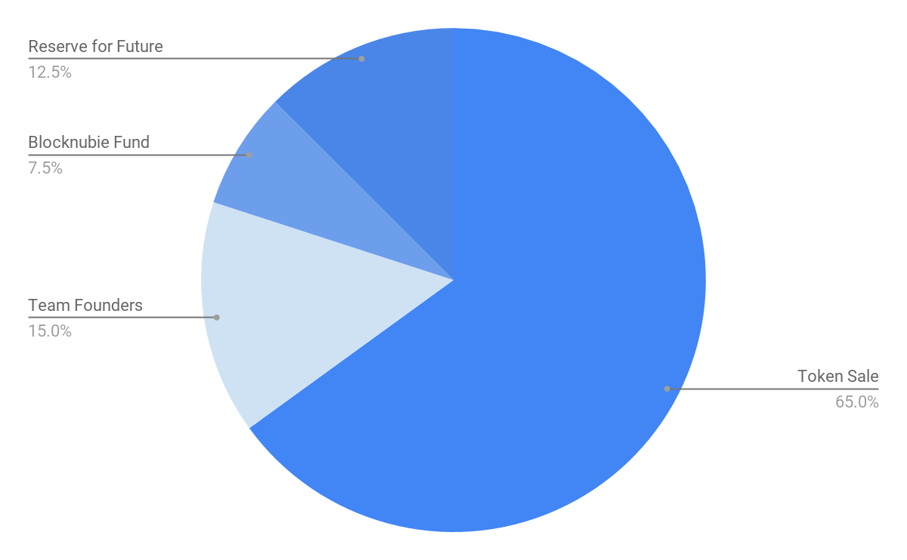

## 

## 

## How can I participate

The NUB Token sale will include the following phases:

|  |  |  |  |
| --- | --- | --- | --- |
| **Stage** | **Private Presale** | **Public Presale** | **Public Sale** |
| **Cap** | €5m | €5m | €25m |
| **Participants** | Blocknubie Community and Strategic Partners | Participant Non-US/CA/CN/TW/HK Participants | Participant Non-US/CA/CN/TW/HK Participants |
| **Period** | 1st - 28th February 2018 | 12th - 26th March 2018 | 9th - 23rd April 2018 |
| **Min. Contribution** | 1 ETH | 10 ETH | 0.1 ETH |
| **Max. Contribution** | 20 ETH | 50 ETH | Determined by # of participants |

## 

## Important Investor Notice

Please note that Blocknubie reserve the right to alter the funding limits and restrictions at Blocknubie’s discretion. This will not affect dilution risks as our core aim is to ensure Nub tokens are distributed fairly among the startup community and ecosystem and that future tokens are available.

## Where can I store my NUB tokens

NUB tokens are based on ERC20 standard and can be stored in any supporting wallet.

## Where and How can I buy NUB tokens

Once the Private Pre-sale has completed at the end of February Blocknubie will announce the details and methodology for taking part in the token purchase.We ask that all community supporters register your interest via the whitelist so that we can ensure participation in the pre-sale. We have had a huge response and will make every effort to contact each person on the whitelist once this closes at the end of February. At this time full roadmap to purchase tokens will be emailed to the private pre-sale participants before being made public.

## KYC and AML Compliance

All transactions at every stage of the sales process will be strictly KYC and AML compliant.

Blocknube are proud to partner with Ominex and US KYC, Investor Accreditation, and digital document signing services built around a compliance rules engine for 150 countries worldwide.   
  
It is the intention of Blocknubie to partner with Ominex for the delivery of a best in class compliant token sale.

## What is Pledge 1% Movement

We are allocating 1% of our minted tokens. These tokens will be given to Pledge 1% over a period of time and will contain vesting terms.   
  
Pledge 1% partners are leading organizations committed to encouraging the early stage companies they work with to make giving back a priority. Further information here http://pledge1percent.org/. Our Team is very passionate about giving back and inspiring early–stage corporate philanthropy.

## What will the proceeds be used for

Any funds raised during the initial contribution period will be used solely for the purpose of the development, benefit and growth of the Blocknubie Ecosystem. The project budget outlined below is based on the scenario where our hard cap goal is met.

* 14% Marketing
* 5% Legal
* 16% Operations
* 65% Development

Blocknubie is a developer-first platform, and our core emphasis is development of the platform. We must ensure the core platform is bug free, secure and scalable

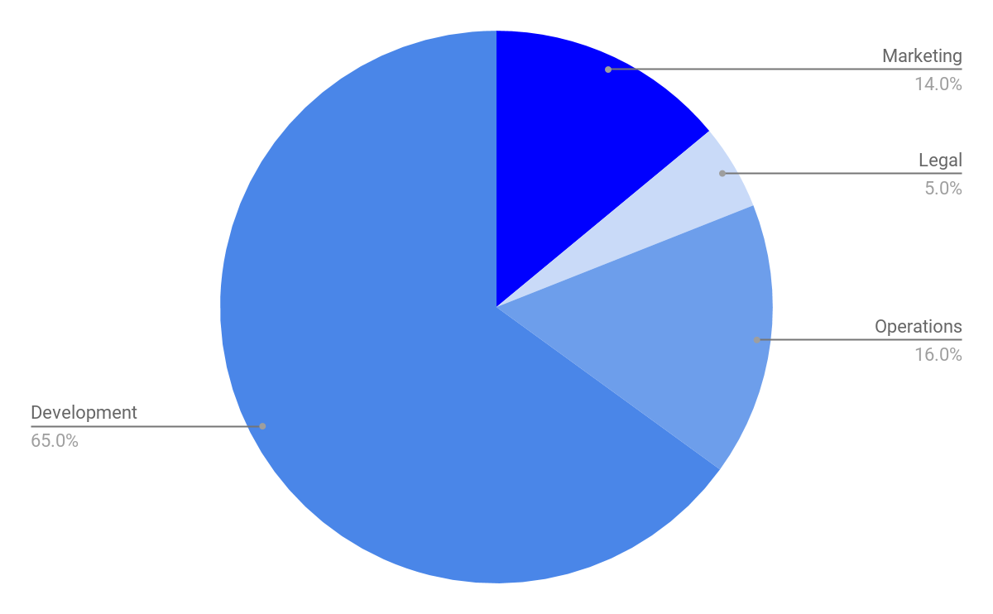

## What is NUB token’s value proposition

The Nub Token is a functional utility token. Nub token will give you a licence to the Platform. Nub token will allow you to enter service contracts with the Blocknubie service providers in the ecosystem.

As we roll out the Blocknubie Fund we plan to make investment decisions and startup pitch battles fully open to the voting of Nub Token holders. Details of this will follow in due course on our community social media and wiki channels.

We will burn any tokens that are not sold. If we do not reach our funding targets we will build our platform on a bootstrapped basis with the available funds and look at alternative funding models such as traditional VCs.

The NUB token is central to the operation of the partner ecosystem. There is a global shortage for this type of platform. As the platform takes in NUBS via licence (SaaS) as well as a percentage of deal flow through the ecosystem we will put tokens back on the market to ensure there is a fair supply.

## Token Bonus and Concentration Risk

Blocknubie is a for profit venture with a strong social venture core. We want to ensure startups and Blockchain companies have access to support and the tools to innovate. As a result our aim is for our token to be fairly distributed and we want to avoid concentration risks. We want the buyers of NUB tokens to believe in the philosophy of the platform rather than looking for speculative gains. As such we have tried to keep our bonus structure as fair to these values as possible.

## Token Vesting

Establishing a mechanism where founders, executives, operators all receive tokens on the basis of a vesting schedule pending their continuous service to an organization is a welcome best practice in ICO Governance.

### Lockups

Blocknubie will attach timed lockups for some investors, as well as founders to ensure disciplined use of proceeds. These will be mediated be mediated by smart contracts. Proposed Vesting Period where founders and core team will vest tokens up to 24 months on a tiered bases.

### Milestones

Milestone-based token release is being used for core team sprints of work. This is being managed on a case by case basis withe the team members.

## Bounties

Bounties will be used on a restricted basis as a process for distribution to include bounty-based incentivization. Bounties will be used for code check and will be used to cover other items such as strategic partnerships. Blocknubie will use bounties on a very limited basis as we feel the token should not be devalued.

## Bonus Structure

**Private Pre-Sale** (Whitelist) 30% Bonus to our community and Advocates and early adopters. To avail of this vesting of 12 months needed.

**Public Pre-ICO**

Wave 1 25%

Wave 2 20%

Wave 3 15%

Wave 4 10%

**ICO Public Sale**

No discount for the period of the main sale,However Blocknubie reserves the right to offer an incentive if it deems appropriate.

## Blocknubie Token Policy Document and approach

Blocknubie will evolve and deepen the output of our Token economics approach. Our core principle is to ensure the Nub token can be used by those who need it to access the platform and service providers therein. Changes to out Token Policy will be made with this intention and we will make all endeavours to protect our investors and supporters interests.

Please consult our wiki and subscribe to our community channels for notifications on updates to this document.